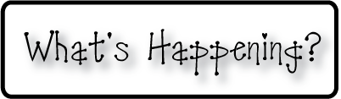border.png

Week of Aug. 19th

OMES

**Mrs. Blair’s Classroom News**



**3rd grade reading-Phonics and word decoding, writing conventions-capitalization, comprehension**

**Have a great week!**

**Writing**- writing complete sentences, nouns

**Reading**- Key details, character, setting and plot

I am so thrilled to be teaching your child this year. We truly have had an awesome start to the school year, and I am extremely impressed with them!

* Please sign your child’s agenda every night and check their homework folder
* Ask your child about MyOn Reader! Login at home and read, read, read!
* Reading Logs are due on the last Friday of each month.
* Early Release day is August 21st
* Assembly “Stronger than a bully” on Friday August 23rd

**Math-** Using addition and subtraction to solve word problems, Touch Math

**Social and Vocational Skills** Showing respect, name calling, personal space