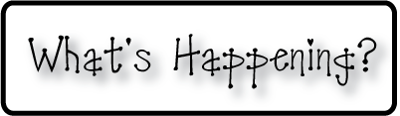

**Mrs. Blair’s Resource Room News**

OMES

Week of September 7, 2016

Novemb 2014

**Mrs. Blair’s Resource Room News**

Week of March 2-6, 2015

Novemb 2014

OMES



**Homework:**

Reading log & response

**This week:**

* September 9th Windy City players production of “Sleeping Beauty”
* September 9 Kona Ice

**Coming Up:**

**Reading**- “A Walk in the Desert”- Key ideas & details, phonics and word recognition, words end in –ed, -ing

Vocabulary Words- animals, early, eyes, full, warm, water

**Writing-** writing a report

**Math-** Counting patterns within 100 and 1000

**Social and Vocational Skills** - School rules and expectations

Contact information:

[angie.blair@bullitt.kyschools.us](mailto:angie.blair@bullitt.kyschools.us) (502) 869-3200

