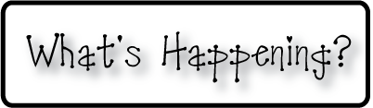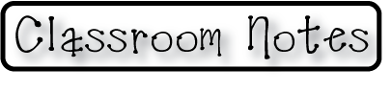

**Mrs. Blair’s Resource Room News**

OMES

Week of September 19, 2016

Novemb 2014

**Mrs. Blair’s Resource Room News**

Week of March 2-6, 2015

Novemb 2014

OMES



**Homework:**

Reading log & response

**Spelling Words:**

That wish patch

When what math

Them shape whale

Itch chase bunch

**This week:**

* Sept 20 High Attendance Day
* Sept 20 Kona Ice
* Sept 23 Fall festival

**Coming Up:**

* Oct 10-14 Fall Break
* Sept 30-Kindergarten Field Trip

**Reading**- “Strongest One”-

Essential question: How does exploration help us find answers?

Inflected endings, blend & segment phonemes, character & setting, predict,

**Writing-** writing a play scene

**Math-** Go Math Chapter 2 Numbers to 1000

Contact information:

[angie.blair@bullitt.kyschools.us](mailto:angie.blair@bullitt.kyschools.us) (502) 869-3200

