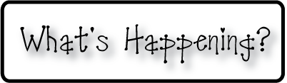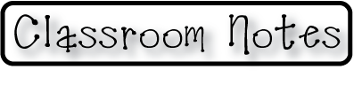

**Mrs. Blair’s Resource Room News**

OMES

Week of September 11, 2016

Novemb 2014

**Mrs. Blair’s Resource Room News**

Week of March 2-6, 2015

Novemb 2014

OMES



**Homework:**

Reading log & response

**Spelling Words:**

Dropped lifted smiled

Dropping lifting smiling

Excited hugged talked

Exciting hugging talking

**This week:**

* Book Fair continues
* PTO Believe Kids Fundraiser
* Kona Ice on Friday

**Coming Up:**

* Sept 20 High Attendance Day
* Sept 20 Kona Ice
* Sept 23 Fall festival

**Reading**- “A Walk in the Desert”- Key ideas & details, phonics and word recognition, words end in –ed, -ing

Vocabulary Words- animals, early, eyes, full, warm, water

**Writing-** punctuation, types of sentences, contractions, a/an, nouns, verbs, adjectives, synonyms, antonyms and capitalization

**Math-** Counting patterns within 100 and 1000

Contact information:

[angie.blair@bullitt.kyschools.us](mailto:angie.blair@bullitt.kyschools.us) (502) 869-3200

