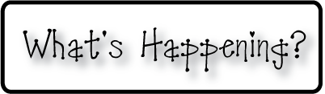border.png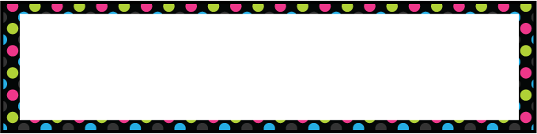

Week of Sept 30th-Oct27th

OMES

**Mrs. Blair’s Classroom News**



**3rd grade reading-Describe characters, decode multisyllable words, apply phonics**

**Have a great week!**

* This is Red Ribbon Week!

Monday-wear red

Tuesday-wear sweat pants

Wednesday-wear neon

Thursday-wear tie dye

Friday- Dress up for picture day!

* Friday is picture day!
* Oct 1st is Family Night at Valu Market from 6:00-8:00pm

**Reading**- Inflectional endings, sequence events, recall details and main topic, punctuation

**Writing**- declarative, interrogative and imperative sentences

**Social and Vocational Skills** -school rules and classroom behavior

**Math-** Counting & sequencing, place value continued