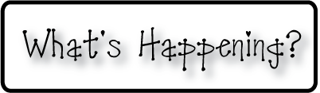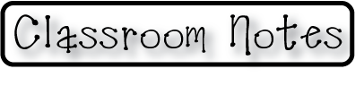

**Mrs. Blair’s Resource Room News**

OMES

Week of October 19-23, 2015

Novemb 2014

**Mrs. Blair’s Resource Room News**

Week of March 2-6, 2015

Novemb 2014

OMES



**Homework:**

This week we are reading the stories “A Fox and a Kit” and “The Zoo in the Park.” Please practice our word wall words and spelling words at home with your child this week.

Word Wall Words: eat, her, this, too

Spelling Words: nap, naps, sit, sits, win, wins, fit, fits, hit, hits, her, too

**Please make sure you sign your child’s agenda each night. Homework packet due Friday**

**This week:**

10/30- Wear Halloween costumes for a dollar donation to charity

10/27 Q1 report cards go home.

**Coming Up:**

11/2- No school-teacher planning

11/3- No school-election day

**Reading**- A Fox and a Kit, inflected endings -s and –es, genre, realistic fiction, expository fiction, main idea and details, compare and contrast, author’s purpose, important ideas.

**Writing-** personal narrative

**Math-** Subtraction strategies - Chapter 4

**Social and Vocational Skills** -Classroom skills-controlling our emotions.

Contact information:

[angie.blair@bullitt.kyschools.us](mailto:angie.blair@bullitt.kyschools.us) (502) 869-3200

**iSTEAM-**See STEAM Website for lesson plans and fantastic links that your child can use at home!

