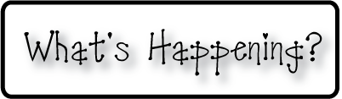border.png

Week of Oct 14th-17th, 2013

OMES

**Mrs. Blair’s Classroom News**



**3rd grade reading-**Foundational skills-fluency, compound words

**Have a fun, safe and long weekend!**

* OMES Fall Festival October 25th
* Thursday’s are DOMINOES PIZZA NIGHT-If you order, 20% donation to Old Mill PTO-Make sure to give your child’s homeroom teacher’s name for class credit.
* No school on Friday October 18th
* Kindergarten Sock Hop

**Reading**- Inflectional endings, consonant blends, short e,

**Writing**- realistic story

**Social and Vocational Skills** -school rules and classroom behavior-video modeling

**Math-** comparing number to shower greater