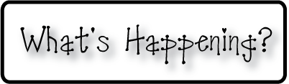

**Mrs. Blair’s Resource Room News**

OMES

Week of October 31st, 2016

Novemb 2014

**Mrs. Blair’s Resource Room News**

Week of March 2-6, 2015

Novemb 2014

OMES



**This week:**

Nov 3-FRC clothing sale at Crossroads ES

**Homework:**

Reading log & response

**Spelling Words (continued):**

**2nd grade**

**aren’t can’t couldn’t didn’t**

**doesn’t don’t hadn’t haven’t**

**he’ll he’s**

**1st grade**

**Bob cob fog got hop cot**

**Lit hot had him are have**

**Reading**- 2nd grade-Abraham Lincoln continued, authors purpose, contractions

1st grade- The Big Top; consonants/d/, /l/, /ll/, /h/

Short O, realism and fantasy

**Writing-** Writing for fluency; life cycle of a pumpkin, biography

**Math-** Go Math Chapter 3

**Coming Up:**

* **Nov 7 No school-Teacher Planning**
* **Nov 8- No school- election day**
* **Nov 11- Veterans Day program 1:30**

Contact information:

[angie.blair@bullitt.kyschools.us](mailto:angie.blair@bullitt.kyschools.us) (502) 869-3200 ext 3264

