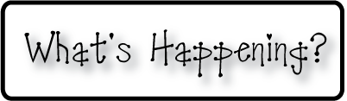border.png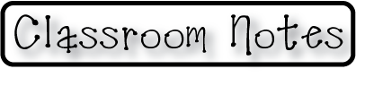

Week of Oct 28-Nov 1, 2013

OMES

**Mrs. Blair’s Classroom News**



**Have a fun and safe weekend!**

* Parent Teacher conferences 10/29/13
* 10/31 Fall/Halloween celebrations at 2:30-students may wear season appropriate tee-shirts. Nothing violent, scary, gory or bloody. No masks, hair spray or make-up allowed.
* Kona Ice truck. Make sure students bring money if they want to purchase a treat.

**Reading**- What does a family do together? words with sh & th

**Writing**- Understand and recognize features of a friendly letter

**Social and Vocational Skills** -relationships skills

**Math-** Chapter 2-Subtraction concepts

**3rd grade reading-**Foundational skills-fluency, consonant blends,