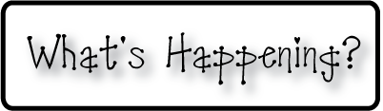

**Mrs. Blair’s Resource Room News**

OMES

Week of October 3rd, 2016

Novemb 2014

**Mrs. Blair’s Resource Room News**

Week of March 2-6, 2015

Novemb 2014

OMES



**This week:**

* **Oct 24-28 Red Ribbon Schools Week**
  + Mon-Super hero shirt
  + Tues-PJ’s
  + Wed-Sweats
  + Thurs- Neon
  + School appropriate Halloween costumes
* **Oct 24 & 27 Parent conferences**
* **Oct 28 Halloween parties in classrooms-all items donated must be store bought**

**Homework:**

Reading log & response

**Spelling Words:**

aren’t

can’t

couldn’t

didn’t

doesn’t

don’t

hadn’t

haven’t

he’ll

he’s

**Reading**- Abraham Lincoln, authors purpose, contractions

**Writing-** Writing for fluency; life cycle of a pumpkin, biography

**Math-** Go Math Chapter 3

**Coming Up:**

* **Nov 7 No school-Teacher Planning**
* **Nov 8- No school- election day**

Contact information:

[angie.blair@bullitt.kyschools.us](mailto:angie.blair@bullitt.kyschools.us) (502) 869-3200 ext 3264

