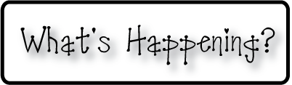border.png

Week of November 4-8, 2013

OMES

**Mrs. Blair’s Classroom News**



**Have a fun and safe weekend!**

* Skating party tonight 6:00-8:00
* Thursday’s are DOMINOES PIZZA NIGHT-If you order, 20% donation to Old Mill PTO-Make sure to give your child’s homeroom teacher’s name for class credit.
* No School Friday November 8th!

**Reading**- How is a school a community? Rhyming words with long a, blend and read words with g & j

**Writing**-Brief composition

**Social and Vocational Skills** -Self-control, positive self-talk

**Math-** Add & subtract within 20

**3rd grade reading-**Review