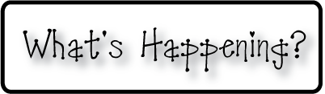

**Mrs. Blair’s Resource Room News**

OMES

Week of November 16, 2015

Novemb 2014

**Mrs. Blair’s Resource Room News**

Week of March 2-6, 2015

Novemb 2014

OMES



**Homework:**

This week we are reading Thanksgiving themed stories.

Word Wall Words(HFW/High Frequency Words): home, many, them, into

**Please make sure you sign your child’s agenda each night. No homework this week!**

**This week:**

11/24 Dinosaur School

11/25-26 No school-Thanksgiving Holiday

**Coming Up:**

12/7 PTO Santa Shop

12/15 Family Literacy Night-Christmas Around the World

**Reading**- Huggly’s Parade, Twas the Night Before Thanksgiving, The First Thanksgiving

**Writing-** Writing workshop-Santa Letter

**Math-** Addition & Subtraction strategies - Chapter 5

**Social and Vocational Skills** -Classroom skills-controlling our emotions, active listening and personal space.

Contact information:

[angie.blair@bullitt.kyschools.us](mailto:angie.blair@bullitt.kyschools.us) (502) 869-3200

**iSTEAM-**See STEAM Website for lesson plans and fantastic links that your child can use at home!

