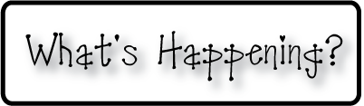

**Mrs. Blair’s Resource Room News**

OMES

Week of November 16, 2015

Novemb 2014

**Mrs. Blair’s Resource Room News**

Week of March 2-6, 2015

Novemb 2014

OMES



**Homework:**

This week we are reading the stories “Get the Egg!”, and “Huggly’s Thanksgiving Parade”. Please continue to practice our word wall words (HFW) and spelling words at home with your child this week.

Word Wall Words(HFW/High Frequency Words): saw, tree, small, your, please, pretty, soon, after, again

Spelling Words: men, ten, jet, bed, red, net, sled, step, leg, wet **Please make sure you sign your child’s agenda each night. Homework packet due Friday**

**This week:**

11/17 Dinosaur School

11/18 Q2 Midterms

11/20 Hat Day for a $1.00 donation to charity

PTO Movie Night

**Coming Up:**

11/25-26 No school-Thanksgiving Holiday

12/15 Family Literacy Night-Christmas Around the World

**Reading**- Week 2: Get the Egg!, Short e , realistic fiction, main idea & details, compare & contrast, sequence, theme, story structure

**Writing-** personal narrative

**Math-** Addition & Subtraction strategies - Chapter 5

**Social and Vocational Skills** -Classroom skills-controlling our emotions, active listening and personal space.

Contact information:

[angie.blair@bullitt.kyschools.us](mailto:angie.blair@bullitt.kyschools.us) (502) 869-3200

**iSTEAM-**See STEAM Website for lesson plans and fantastic links that your child can use at home!

