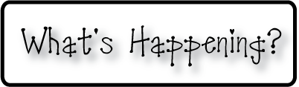

**Mrs. Blair’s Resource Room News**

OMES

Week of November 14, 2016

Novemb 2014

**Mrs. Blair’s Resource Room News**

Week of March 2-6, 2015

Novemb 2014

OMES



**This week:**

**Friday is PTO Movie Night- “Finding Dory”**

**Homework:**

Reading log & response

**Spelling Words:**

**2nd grade**

**person nurse dirt turn**

**birth serve curb curl**

**skirt purse turtle her**

**Vocabulary words-above, ago, enough, toward, whole, word**

**1st grade**

**he is to with three bed**

**job rag wig beg jog Kim**

**Reading**-

2nd grade-“Scarcity” **continued**;  /er/, /ir/, and /ur; facts and details;

1st grade- School Day; consonants/r/, /w/, /j/, /k/

Short e,

**Writing-** Writing for fluency; biography, opinion

**Math-** Go Math Chapter 3

**Coming Up:**

* Nov 21 Picture retake day
* Nov 23, 24, 25-Thanksgiving Break
* Dec 8th- Family Literacy Night

Contact information:

[angie.blair@bullitt.kyschools.us](mailto:angie.blair@bullitt.kyschools.us) (502) 869-3200 ext 3264

