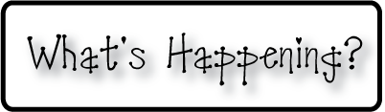

**Mrs. Blair’s Resource Room News**

OMES

Week of November 30, 2015

Novemb 2014

**Mrs. Blair’s Resource Room News**

Week of March 2-6, 2015

Novemb 2014

OMES



**Homework:**

This week we are reading the stories, “ A Big Fish for Max and Fishing withTad.”Please continue to practice our word wall words (HFW) and spelling words at home with your child this week.

Word Wall Words(HFW/High Frequency Words): catch, put, good, said, no, want, please, pretty, soon, after, again

Spelling Words: fish, with, shop, ship, then, rush, trash, shut, shell, thin

**Please make sure you sign your child’s agenda each night. Homework packet due Friday**

**This week:**

12/1 Dinosaur School

**Coming Up:**

12/7 PTO Santa Shop

12/15 Family Literacy Night-Christmas Around the World 6:00-7:30

**Reading**- Week 1: A Big Fish, vowel sound in ball a al, nonfiction, realistic fiction, animal fantasy, sequence, draw conclusions, predict and set purpose, character.

**Writing-** writing a friendly letter

**Math-** Addition & Subtraction strategies - Chapter 5 continued

**Social and Vocational Skills** -Classroom skills-controlling our emotions, active listening and personal space.

Contact information:

[angie.blair@bullitt.kyschools.us](mailto:angie.blair@bullitt.kyschools.us) (502) 869-3200

**iSTEAM-**See STEAM Website for lesson plans and fantastic links that your child can use at home!

