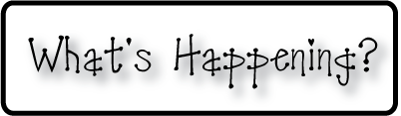.

**Mrs. Blair’s Resource Room News**

OMES

Week of May 9-13, 2016

Novemb 2014

**Mrs. Blair’s Resource Room News**

Week of March 2-6, 2015

Novemb 2014

OMES



**Homework:**

This week we will begin the story, “Mama’s Birthday Present”. Please practice our word wall words (HFW) and spelling words at home with your child this week.

We will continue our new reading response log. Students should read a book of their choice and respond each night.

**HFW:** about, surprise, enjoy, worry, give, would

**Phonics and Spelling:** way, day, gray, train, tail, may, mail, play, rain, afraid

**Amazing words:** celebrate, grateful, rarest, genuine, cherish, delicate, loot

**Please make sure you sign your child’s agenda each night. Homework due Friday.**

**This week:**

May 9-10 BOGO Book Fair

May 11-13, 13-16 K-PREP Testing

**Coming Up:**

May 17 No School

May 20 Mini Relay for Life Fundraiser

May 27 Field Day, KONA Ice

May 30 Memorial Day- No School

May 31 Make up Day

June 1 Make Up Day LAST DAY FOR STUDENTS

June Closing Day for teachers

**Reading**- Week 1: “Mama’s Birthday Present”

Phonics-vowel digraphs ai, ay, adjectives, summarize

**Writing and language-**organization, friendly letter, adjectives

**Math-** Chapter 12- Two-Dimensional Geometry

**Social and Vocational Skills** -Working as team to get the job done!

Contact information:

[angie.blair@bullitt.kyschools.us](mailto:angie.blair@bullitt.kyschools.us) (502) 869-3200

**iSTEAM-**See STEAM Website for lesson plans and fantastic links that your child can use at home!

