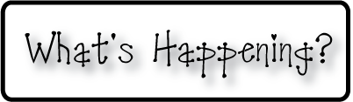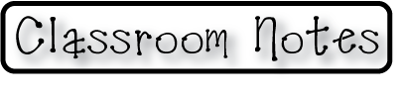

**Mrs. Blair’s Resource Room News**

OMES

Week of May 1st, 2017

Novemb 2014

**Mrs. Blair’s Resource Room News**

Week of March 2-6, 2015

Novemb 2014

OMES



**Here’s what’s happening this week:**

May 1-5 Educator Appreciation Week

May 5 No School

**Homework:**

Reading log & response

**Spelling Words:**

Cheerful visitor slowly

Weekly teacher helper

Hardly graceful yearly

Quickly fighter sailor

**Vocabulary words-** building, burning, masks, quickly, roar, station, tightly

**Reading**- “Fire Fighter ”

I can read a passage and distinguish between fact and opinion. I can identify and spell words ending with the suffixes -ful, -ly, -er, and -or.  I can identify and use pronouns correctly in a sentence.

**Writing-** Expository writing

**Math-** Go Math Chapter 8- Length in Customary Units

**Coming Up:**

5/10-12 & 15-16 K-PREP Testing

May 18, 19, 20 BOGO Book fair

May 25th Last day for students- Field Day & Kona Ice

Contact information:

[angie.blair@bullitt.kyschools.us](mailto:angie.blair@bullitt.kyschools.us) (502) 869-3200 ext 3264

