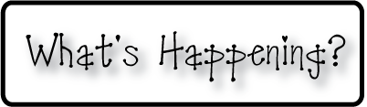

**Mrs. Blair’s Resource Room News**

OMES

Week of March 7-11, 2016

Novemb 2014

**Mrs. Blair’s Resource Room News**

Week of March 2-6, 2015

Novemb 2014

OMES



**Homework:**

This week we will begin the story, “The Class Pet””. Please practice our word wall words (HFW) and spelling words at home with your child this week.

HFW: away, house, very, car, our, friends, school

Amazing words: features, natural, tumble, nibble, wriggle, swoop, crumble, nudges, mature

Phonics and spelling: fix, fixes, kiss, kisses, class, classes, wish, wishes, bus, buses

**Please make sure you sign your child’s agenda each night. Homework packet due Friday.**

**This week:**

March 7-11 Book Fair

3/8- **Book Fair Parent Night 4:00-6:00**

3/11- 1:30 Family celebration: Brag Tag awards in the cafeteria.

**Coming Up:**

March 7-11 Book Fair

Dollar bill charity for UK vs UL Money Wars fundraiser.

3/16 Benjamin Franklin play for grades K-5

3/17 Kona Ice returns!

3/18 Career Day!

3/21 No School for students-Teacher Planning Day

**Reading**- Week 1: “The Class Pet” Give descriptions, verbs that do not add –s,

**Writing and language-**Narratives, singular and plural nouns with matching verbs, give descriptions, verbs that do not add –s

**Math-** Chapter 9- Measurement

**Social and Vocational Skills** -Working as team to get the job done!

Contact information:

[angie.blair@bullitt.kyschools.us](mailto:angie.blair@bullitt.kyschools.us) (502) 869-3200

**iSTEAM-**See STEAM Website for lesson plans and fantastic links that your child can use at home!

