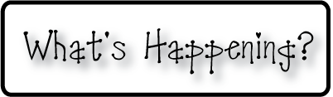

**Mrs. Blair’s Resource Room News**

OMES

Week of March 6th, 2017

Novemb 2014

**Mrs. Blair’s Resource Room News**

Week of March 2-6, 2015

Novemb 2014

OMES



**Reading**- “A Froggy Fable” & “A Southern Ranch”

I can read a passage and draw conclusions using my background knowledge and evidence from the text.  I can identify and spell words containing the final syllable -le.  I can create a fictional narrative.  I can identify and use adjectives to make my writing more descriptive.

**Here’s what’s happening this week:**

3/6-10-Our Old Mill Penny War Fundraiser for Lymphoma/Leukemia Research

**Homework:**

Reading log & response

**Spelling Words:**

**2nd grade**

Ankle title apple

Cable purple able

Bugle bundle bubble

Giggle sparkle tickle

**Vocabulary words-** clearing, crashed, perfect, pond, spilling, splashing, traveled

**1st grade- Long O**

Bright high lie

Light might night

Pie right tie

tight

**HFW-High Frequency Words:**

Above, eight, laugh, moon, touch

**Writing-**   Write narratives in which they recount a well-elaborated event or short sequence of events, include details to describe actions, thoughts, and feelings, use temporal words to signal event order, and provide a sense of closure.

**Math-** Go Math Chapter 6- Adding and subtracting 3 digit numbers.

**Coming Up:**

Last day of 3rd quarter 3/13

3/17 Snow make-up day

3/20 No school-teacher planning day

Book Fair 3/23-24, 27-31

Spring Break April 3-7

Contact information:

[angie.blair@bullitt.kyschools.us](mailto:angie.blair@bullitt.kyschools.us) (502) 869-3200 ext 3264

