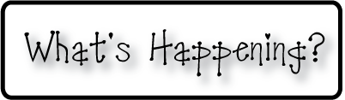

**Mrs. Blair’s Resource Room News**

OMES

Week of March 20th, 2017

Novemb 2014

**Mrs. Blair’s Resource Room News**

Week of March 2-6, 2015

Novemb 2014

OMES



**Reading**- “Life Cycle of a Pumpkin”

I can read a passage and sequence the steps in the pumpkin life cycle.  I can identify and spell words containing the vowel patterns /oo/ and /u/.  I can create a fictional narrative.  I can identify and use adjectives to make my writing more descriptive.

**Here’s what’s happening this week:**

3/20 No school-teacher planning day

3/24 Parent teacher conferences

**Homework:**

Reading log & response

**Spelling Words:**

**2nd grade**

Cook stood full

wood July shook

push pull brook

book hood put

**Vocabulary words-** bumpy, fruit, harvest, root, smooth, soil, vine

**1st grade- Long O**

Brown clown cow

Crowd down frown

Growl how now

town

**HFW-High Frequency Words:**

Along, behind, eyes, never, pulling, toward

**Writing-**   Write narratives in which they recount a well-elaborated event or short sequence of events, include details to describe actions, thoughts, and feelings, use temporal words to signal event order, and provide a sense of closure.

**Math-** Go Math Chapter 7- Money & Time

**Coming Up:**

Book Fair 3/27-31

Spring Break April 3-7

Contact information:

[angie.blair@bullitt.kyschools.us](mailto:angie.blair@bullitt.kyschools.us) (502) 869-3200 ext 3264

