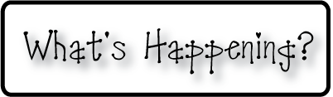

**Mrs. Blair’s Resource Room News**

OMES

Week of January 4th, 2017

Novemb 2014

**Mrs. Blair’s Resource Room News**

Week of March 2-6, 2015

Novemb 2014

OMES



**Welcome back!**

**I hope everyone had a safe and enjoyable holiday break!**

**This week will be a review and a refresher for class and school expectations.**

**We will continue reading, writing and math but we will not start a new unit until next week.**

**Have a great week!**

**This week:**

**Homework:**

Reading log & response

**Spelling Words:**

None this week

**Vocabulary words-**

**1st grade**

None this week

**High Frequency Words**:

**Reading**- Review

**Writing-** Writing for fluency; Journal write,

**Math-** Go Math Chapter 4

**Coming Up:**

1/11 Second quarter report cards go home.

Contact information:

[angie.blair@bullitt.kyschools.us](mailto:angie.blair@bullitt.kyschools.us) (502) 869-3200 ext 3264

