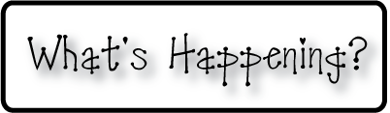

**Mrs. Blair’s Resource Room News**

OMES

Week of January 23rd, 2017

Novemb 2014

**Mrs. Blair’s Resource Room News**

Week of March 2-6, 2015

Novemb 2014

OMES



**Reading**- “Dear Juno”

I can read a passage and visualize the characters and events that are happening.  I can read a passage and draw conclusions based on the characters and events in the story.  I can write a friendly letter using the correct format, including using commas correctly.  I can identify and spell long o words containing /o/, /oa/, and /ow/.  I can identify the correct verbs to use with singular and plural nouns.

**This week:**

* Jan 27th PTO movie night

**Homework:**

Reading log & response

**Spelling Words:**

**2nd grade**

Goat hold show

Most bowl float

Toast ago open

Told toad slow

**Vocabulary words-**answer, company, faraway, parents, picture, school, wash

**1st grade-**

**Short o**

Box cot dog

Dot flock lot

Mom off on

**plural –s; /z/**:

flocks, cots, dogs, lids, locks, hogs

**Writing-** Students will read a friendly letter and begin a prewriting organizer.

**Math-** Go Math Chapter 5

**Coming Up:**

* Feb 17th is a snow make up day
* Feb 20-No school, President’s Day
* Feb 21-No School, teacher planning day

Contact information:

[angie.blair@bullitt.kyschools.us](mailto:angie.blair@bullitt.kyschools.us) (502) 869-3200 ext 3264

