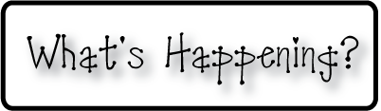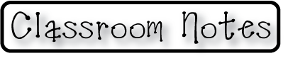

**Mrs. Blair’s Resource Room News**

OMES

Week of January 11-15, 2016

Novemb 2014

**Mrs. Blair’s Resource Room News**

Week of March 2-6, 2015

Novemb 2014

OMES



**Homework:**

This week we are continuing the story “The Big Circle”. Please continue to practice our word wall words (HFW) and spelling words at home with your child this week.

HFW: around, grow, find, under, food, water

Amazing words: environment, thrive, slimy, capture, require, inhale, sludge, creature

Phonics and spelling: Long U and silent E; huge, tube, cute, mule, June, use, flute, rule, cube, rude

**Please make sure you sign your child’s agenda each night. Homework packet due Friday.**

**This week:**

1/18 No School MLK Day

1/22 Hat Day for charitable donation

**Coming Up:**

2/1 No School-Teacher Planning Day

**Reading**- Week 1: “Life in the Forest” inflected ending-ed, u_e, long e,nonfiction, labels, diagrams, food chains, author’s purpose, cause and effect, background knowledge

**Writing-** Young Author

**Math-** Chapter 7- greater than and less than

**Social and Vocational Skills** -Expressing your feelings-dealing with hurt

Contact information:

[angie.blair@bullitt.kyschools.us](mailto:angie.blair@bullitt.kyschools.us) (502) 869-3200

**iSTEAM-**See STEAM Website for lesson plans and fantastic links that your child can use at home!

