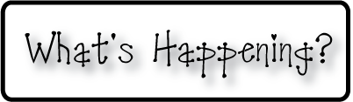

**Mrs. Blair’s Resource Room News**

OMES

Week of February 8-12, 2016

Novemb 2014

**Mrs. Blair’s Resource Room News**

Week of March 2-6, 2015

Novemb 2014

OMES



**Homework:**

This week we are continuing the story “Honey Bees”. Please continue to practice our word wall words (HFW) and spelling words at home with your child this week.

HFW: also, other, family, some, new, their

Amazing words: individual, special, slither, eagerly, industrious, creep, romp, wander

Phonics and spelling: Lone e,ee- feet, we, she, be, he, green, tree, see, me, week

**Please make sure you sign your child’s agenda each night. Homework packet due Friday.**

**This week:**

2/12- Sock Hop K-3

**Coming Up:**

2/15 No School Presidents Day

**Reading**- Week 1: “Honey Bees” Nonfiction, compare and contrast, sequence, draw conclusion, questioning, main idea, Long e, ee

**Writing-** Young Author

**Math-** Chapter 8- Add and subtract 2 digit numbers

**Social and Vocational Skills** -Working as team to get the job done!

Contact information:

[angie.blair@bullitt.kyschools.us](mailto:angie.blair@bullitt.kyschools.us) (502) 869-3200

**iSTEAM-**See STEAM Website for lesson plans and fantastic links that your child can use at home!

