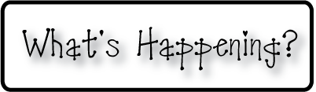

**Mrs. Blair’s Resource Room News**

OMES

Week of February 6th, 2017

Novemb 2014

**Mrs. Blair’s Resource Room News**

Week of March 2-6, 2015

Novemb 2014

OMES



**Reading**- “Anansi Goes Fishing”

I can read a passage and compare and contrast the characters and events.  I can create my own narrative poem.  I can identify and spell compound words.  I can identify the correct verbs for past, present, and future the correct verbs to use with singular and plural nouns.

**This week:**

* Feb 6th Yearbook Sales begin
* Feb 7th Sock Hop for 2nd & 3rd grades

**Homework:**

Reading log & response

**Spelling Words:**

**2nd grade**

Basketball someone weekend

Something birthday riverbank

Bathtub backyard driveway

Bedtime raindrop mailbox

**Vocabulary words-**been, believe, caught, finally, today, tomorrow, whatever

**1st grade- Long O**

Bone broke choke

Chose close code

Drove froze globe

**Contractions:**

it’ll, she’ll, I’m, can’t, don’t, isn’t wasn’t, he’ll, hadn’t, hasn’t

**Writing-**   Students will read a narrative poem and use the prewriting organizer on to begin their own poem.

**Math-** Go Math Chapter 5

**Coming Up:**

* Feb 17th is a snow make up day
* Feb 20-No school, President’s Day
* Feb 21-No School, teacher planning day

Contact information:

[angie.blair@bullitt.kyschools.us](mailto:angie.blair@bullitt.kyschools.us) (502) 869-3200 ext 3264

