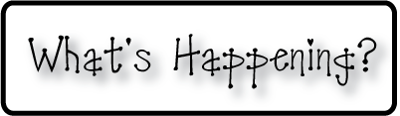

**Mrs. Blair’s Resource Room News**

OMES

Week of February 22-26, 2016

Novemb 2014

**Mrs. Blair’s Resource Room News**

Week of March 2-6, 2015

Novemb 2014

OMES



**Homework:**

This week we will begin the story “A Place to Play”. Please continue to practice our word wall words (HFW) and spelling words at home with your child this week.

HFW: always, everything, things, become, nothing, day, stays

Amazing words: growth, public, teeter, makeshift, population, shuffle, crooked, spindly

Phonics and spelling: vowel sounds of Y: by, handy, lucky, my, try, fly, silly, sunny, cry, puppy

**Please make sure you sign your child’s agenda each night. Homework packet due Friday.**

**This week:**

**Coming Up:**

**Reading**- Week 1: “A Place to Play” Nonfiction, fiction, narrative nonfiction, sequence, author’s purpose, summarize.

**Writing-** Young Author

**Math-** Chapter 8- Add and subtract 2 digit numbers

**Social and Vocational Skills** -Working as team to get the job done!

Contact information:

[angie.blair@bullitt.kyschools.us](mailto:angie.blair@bullitt.kyschools.us) (502) 869-3200

**iSTEAM-**See STEAM Website for lesson plans and fantastic links that your child can use at home!

