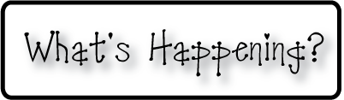border.png

Week of February 17-21, 2014

OMES

**Mrs. Blair’s Classroom News**



* 2/20 OMES Domino’s pizza fundraiser night
* Remember to record your book read in your reading log!
* All car riders must be in the cafeteria for breakfast by 8:40 each morning

**Writing**- Lists

**Reading**- Changes in a garden, author’s purpose, final phonemes, words with-ed

**Social and Vocational Skills** Appropriate behaviors- when to interrupt, hints that you’re doing okay, considering others

**Math-** Chapter 8 adding and subtracting within 20

**3rd grade reading-** Uniques traits, fact and opinion, suffixes-es, -or, -ess, -ist, questioning

Do more of what makes you awesome!