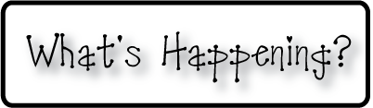

**Mrs. Blair’s Resource Room News**

OMES

Week of December 7, 2015

Novemb 2014

**Mrs. Blair’s Resource Room News**

Week of March 2-6, 2015

Novemb 2014

OMES



**Homework:**

This week we are reading the stories, “A Big Fish for Max and Fishing with Tad”, and “The Polar Express”. Please continue to practice our word wall words (HFW) and spelling words at home with your child this week.

Word Wall Words (HFW/High Frequency Words): catch, put, good, said, no, want, please, pretty, soon, after, again

Spelling Words: fish, with, shop, ship, then, rush, trash, shut, shell, thin

**Please make sure you sign your child’s agenda each night. Homework packet due Friday.**

**This week:**

12/7 PTO Santa Shop

12/8 Dinosaur School

**Coming Up:**

12/15 Family Literacy Night-Christmas Around the World 6:00-7:30

12/18 Holiday parties from 2:30-3:30. Students may bring in packaged snacks to share with class.

**Reading**- Week 2: A Big Fish, vowel sound in ball a al, nonfiction, realistic fiction, animal fantasy, sequence, draw conclusions, predict and set purpose, character.

**Writing-** writing a friendly letter

**Math-** Count and model numbers - Chapter 6

**Social and Vocational Skills** -Expressing your feelings

Contact information:

[angie.blair@bullitt.kyschools.us](mailto:angie.blair@bullitt.kyschools.us) (502) 869-3200

**iSTEAM-**See STEAM Website for lesson plans and fantastic links that your child can use at home!

