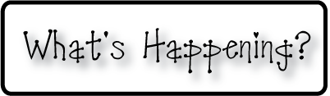

**Mrs. Blair’s Resource Room News**

OMES

Week of December 5th, 2016

Novemb 2014

**Mrs. Blair’s Resource Room News**

Week of March 2-6, 2015

Novemb 2014

OMES



**This week:**

* Dec 5th -9th- Santa Shop
* Dec 9th “The Nutcracker” assembly
* Dec 8th- Family Literacy Night 6:30-7:30

**Homework:**

Reading log & response

**Spelling Words:**

**2nd grade**

**Main wait say**

**Away play raise**

**Brain paint stay**

**Today tray tail**

**Vocabulary words-behind, brought, door, everybody, minute, promise, sorry**

**1st grade**

Ad jab rat

Back an Sam

Sad lad bad

Jam sag bag

**High Frequency Words**:

Jack black back lack Mack pack quack

**Reading**-

2nd grade-“One Good Turn Deserves Another” :  a, ai, and ay; inferring, compare/contrast, author’s purpose.

1st grade- “Sam, Come back!”; final *ck*; short *a*

**Writing-** Writing for fluency; Journal write, What I know about reindeer

**Math-** Go Math Chapter 4

**Coming Up:**

* Dec 16th last day of school
* Jan 4th students return to school

Contact information:

[angie.blair@bullitt.kyschools.us](mailto:angie.blair@bullitt.kyschools.us) (502) 869-3200 ext 3264

