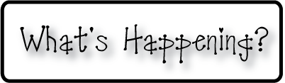border.png

Week of December 2-6, 2013

OMES

**Mrs. Blair’s Classroom News**



**Have a fun, safe and happy holiday season!**

* Santa Shop at school December 9-13
* Family Literacy Night December 10th from 6:00-8:00
* Thursday’s are DOMINOES PIZZA NIGHT-If you order, 20% donation to Old Mill PTO-Make sure to give your child’s homeroom teacher’s name for class credit.

**Writing**-Description

**Social and Vocational Skills** calm down strategies

**Reading**- Plant and animal communities, author’s purpose, long u & e

**Math-** subtraction strategies

**3rd grade reading-**Foundational skills-fluency, verb tenses, sequence and describe, prefix & suffix