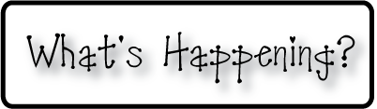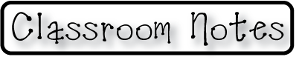

**Mrs. Blair’s Resource Room News**

OMES

Week of December 14, 2015

Novemb 2014

**Mrs. Blair’s Resource Room News**

Week of March 2-6, 2015

Novemb 2014

OMES



**Homework:**

This week we are reading the stories, “Who Works Here?”, and “The Christmas Candle”. Please continue to practice our word wall words (HFW) and spelling words at home with your child this week.

Word Wall Words (HFW/High Frequency Words): live, who, out, work, people

Spelling Words: like, time, dime, kite, ride, white, hide, smile, bike, ice

**Please make sure you sign your child’s agenda each night. Homework packet due Friday.**

**This week:**

12/15 Christmas Around the World Family Literacy Night 6:00-7:30

12/15 Dinosaur School

12/18 Holiday parties from 2:30-3:30. Students may bring in packaged snacks to share with class.

**Coming Up:**

12/21 thru 1/4 Winter Break

**Reading**- Week 1: Who Works Here?, vowel sound long i, nonfiction, narrative nonfiction, time designations, author’s purpose, compare and contrast.

**Writing-** explanation

**Math-** Count and model numbers - Chapter 6

**Social and Vocational Skills** -Expressing your feelings-dealing with anger

Contact information:

[angie.blair@bullitt.kyschools.us](mailto:angie.blair@bullitt.kyschools.us) (502) 869-3200

**iSTEAM-**See STEAM Website for lesson plans and fantastic links that your child can use at home!

