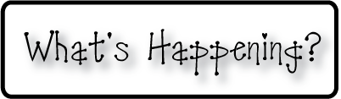

**Mrs. Blair’s Resource Room News**

Week of December 1st, 2014

Novemb 2014

OMES



**Homework:**

* Reading Log
* Tuesday-Worksheet
* Sight word log
* Sign Agenda Daily

**This week:**

MAP Testing Begins

**Coming Up:**

12/11 Family Reading Night-Christmas Around the World

12/8-11- Santa Shop opens

12/22-Christmas Break

**Reading**- Upper case and lower case Ii, blend sounds to say words, sequence



**Writing-**Review upper and lower case letters, spacing, journal write, summarizing a story

**Social and Vocational Skills** -Transitions, Listening, Asking for help, Emotions

**iSTEAM-**Compass

**Math-** Chapter 4-Represent and compare numbers to 10

Contact information:

[angie.blair@bullitt.kyschools.us](mailto:angie.blair@bullitt.kyschools.us)

Planning from 12:00-1:00

(502) 869-3200