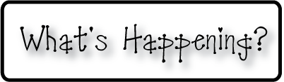border.pngA

Week of April 28-May 2, 2014

OMES

**Mrs. Blair’s Classroom News**



* 4/28-5/1 Book Fair
* No School 5/2
* Remember to record your book read in your reading log
* All car riders must be in the cafeteria for breakfast by 8:40 each morning

**Writing**- Directions

**Reading**- Treasures found in your neighborhood, cause & effect, two syllable words, suffixes –il, -ful, adjectives that compare

**Social and Vocational Skills** Winning and NOT winning: Behavior discussion, social stories, video modeling,

**Math-** Chapter 11: Geometry

**3rd grade reading-** Fluency, Cause & Effect, Inferring, abbreviations, granting freedom



Coming up: Quote of the week:

“No one is perfect-- that’s why pencils have erasers“

--Author unknown