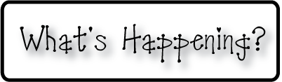

**Mrs. Blair’s Resource Room News**

OMES

Week of April 10th, 2017

Novemb 2014

**Mrs. Blair’s Resource Room News**

Week of March 2-6, 2015

Novemb 2014

OMES



**Here’s what’s happening this week:**

**Homework:**

Reading log & response

**Spelling Words:**

**2nd grade**

**Vocabulary words-** Adjust, landmark, unexpected, quiver, tease, foreign, accent, forlorn

**1st grade-** Long a spelled ai and ay/Possessives

**HFW-High Frequency Words:**

Our, know, now, than, new, day, made, my

**Reading**- “The Night the Moon Fell ”

I can read a passage and describe the plot and theme.  I can create a fictional narrative.  I can identify adverbs that tell when and where.  I can identify and spell two-syllable, compound words.

**Writing-** Narrative poems

**Math-** Go Math Chapter 7- Money & Time

**Coming Up:**

MAP Testing

May 5 No School

May 18, 19, 22 Book fair

May 25th Last day for students

Contact information:

[angie.blair@bullitt.kyschools.us](mailto:angie.blair@bullitt.kyschools.us) (502) 869-3200 ext 3264

