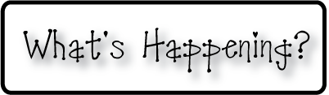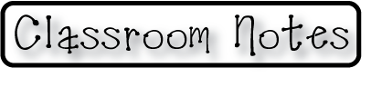

**Mrs. Blair’s Resource Room News**

OMES

Week of January 11-15, 2016

Novemb 2014

**Mrs. Blair’s Resource Room News**

Week of March 2-6, 2015

Novemb 2014

OMES



**Homework:**

This week we are continuing the story “The Big Circle”. Please continue to practice our word wall words (HFW) and spelling words at home with your child this week.

Word Wall Words (HFW/High Frequency Words): down, there, inside, together, now

Spelling Words: home, woke, hose, stone, hope, those, joke, rose, bone, rode

**Please make sure you sign your child’s agenda each night. Homework packet due Friday.**

**This week:**

MAP testing continues

1/12 Q2 report cards gohome

**Coming Up:**

1/18 No School MLK Day

1/22 Hat Day for charitable donation

2/1 No School-Teacher Planning Day

**Reading**- Week 1: “The Big Circle” vowel sound long o, expository nonfiction, sequence, drawing conclusions, inferring, cause and effect. Captions and labels

**Writing-** Young Author

**Math-** Count and model numbers - Chapter 6 continued

**Social and Vocational Skills** -Expressing your feelings-dealing with hurt

Contact information:

[angie.blair@bullitt.kyschools.us](mailto:angie.blair@bullitt.kyschools.us) (502) 869-3200

**iSTEAM-**See STEAM Website for lesson plans and fantastic links that your child can use at home!

