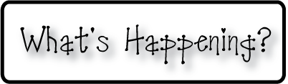border.png

Week of December 9-13, 2013

OMES

**Mrs. Blair’s Classroom News**



**Have a fun, safe and happy holiday season!**

* Santa Shop at school December 9-13
* Family Literacy Night-Christmas Around the World- December 10th from 6:00-8:00
* Christmas food Drive- Bring in a nonperishable item for our community

**Writing**-Expository paragraph

**Social and Vocational Skills** making a decision, helping others

**Reading**- Insect communities compare and contrast, distinguish between long e and /e/

**Math-** subtraction strategies

**3rd grade reading-**Foundational skills-fluency, irregular verbs, predict, consonant patterns wr, kn, gn, st,